Project Design Phase-II
Technology Stack (Architecture & Stack)
Date | 30 September 2026
Team ID | SWTID-2026-8157
Project Name | BlogNest – AI-Powered Blog Content Generation & Management Platform
Maximum Marks | 4 Marks

Technical Architecture:
The deliverable includes the architectural diagram below and the information in Table-1 and Table-2.
Example: BlogNest – AI-Powered Blog Content Platform
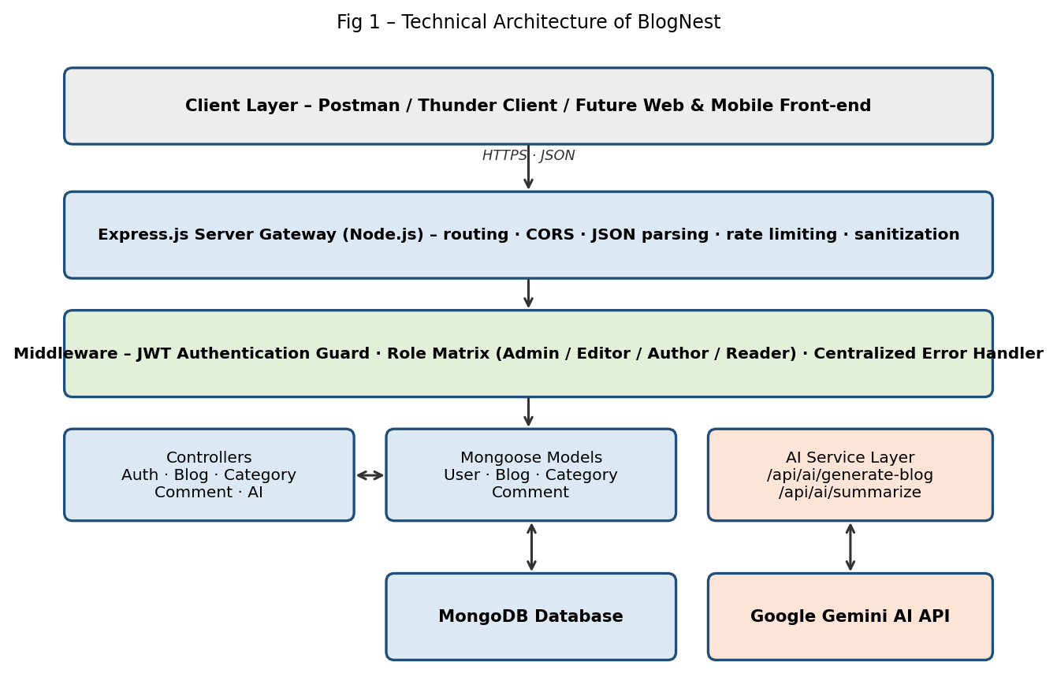
Table-1 : Components & Technologies:
S.No | Component | Description | Technology
1 | User Interface | How the user interacts with the application – REST API consumed through API clients (headless backend) | Postman / Thunder Client (future: HTML, CSS, JavaScript / React)
2 | Application Logic-1 | Authentication, JWT issuance and role-based access control | Node.js, Express.js, jsonwebtoken, bcrypt.js
3 | Application Logic-2 | Blog, category and comment management (CRUD and moderation) | Node.js, Express.js (MVC controllers)
4 | Application Logic-3 | AI blog generation and summarization | Google Gemini AI SDK (@google/genai)
5 | Database | Users, Blogs, Categories and Comments collections | MongoDB with Mongoose ODM
6 | Cloud Database | Hosted database option for deployment | MongoDB Atlas (optional)
7 | File Storage | Cover image / media metadata paths stored with posts | Local file system (media path stored in MongoDB)
8 | External API | AI content generation and summarization | Google Gemini API
9 | Machine Learning Model | Generative language model for blog drafts and summaries | Google Gemini (hosted via API)
10 | Infrastructure (Server / Cloud) | Local: Node.js server on Windows / macOS / Linux. Cloud: any Node.js host with a MongoDB connection | Local (npm start / nodemon); cloud-ready

Table-2: Application Characteristics:
S.No | Characteristics | Description | Technology
1 | Open-Source Frameworks | Open-source frameworks and libraries used | Express.js, Mongoose, cors, morgan, dotenv, nodemon
2 | Security Implementations | Password hashing, token-based auth, role checks, sanitization against XSS and NoSQL injection, rate limiting, secrets in .env | bcrypt.js, JWT, Role Matrix middleware, request sanitization, OWASP practices
3 | Scalable Architecture | Layered MVC design with modular routes, controllers, models and services; stateless API | Node.js / Express (3-tier, modular)
4 | Availability | Database connection established before serving requests; stateless instances can run behind a load balancer | MongoDB, Node.js process manager / load balancer (deployment)
5 | Performance | Schema-driven queries with indexes, lightweight JSON responses, cacheable public reads (planned) | Mongoose indexes, caching (future enhancement)

References:
- https://nodejs.org/docs

- https://expressjs.com

- https://mongoosejs.com

- https://ai.google.dev

